**Chapter 16: Waves  
*Please remember to photocopy 4 pages onto one sheet by going A3→A4 and using back to back on the photocopier.***

**The speed of sound is 340 m s-1**

**The speed of light is 3 × 108 m s-1**

**Questions to make you think**

1. Can you experience a shockwave in space – why not?
2. You must have noticed that food in a microwave oven doesn’t get heated evenly – why not (see image on page 6)?
3. In 1924 American astronomer Edwin Hubble announced the existence of other galaxies fundamentally changing our view of the universe. In 1929 he discovered that these galaxies were all moving away from us; the universe was therefore expanding. What was his evidence for this?

**Notes**

**A wave** is a means of transferring energy from one place to another by oscillation.   
It turns out that all waves can be divided into two separate categories – transverse and longitudinal.

**Transverse waves**

**A *transverse wave*** is a wave where the direction of vibration is *perpendicular* to the direction in which the wave

travels.

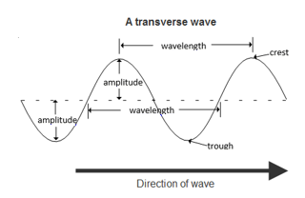  
**Examples**

1. Light waves.
2. Radio waves.
3. Waves on a rope.
4. Water waves.

**Longitudinal Waves**

**A *longitudinal wave*** is a wave where the direction of vibration is *parallel* to the direction in which the wave travels.

**Examples**

1. Sound waves in a solid, liquid or gas.
2. Compression waves on a spring.

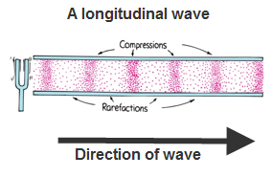

compression

rarefaction

wavelength

**Terms used to describe a wave**

The **wavelength** (*λ*)of a wave is the distance from one point on the wave to the corresponding point on the next cycle.

The **frequency** (*f*) of a wave is a measure of the number of oscillations (full cycles) of the wave per second*.

The **periodic time** (*T*) of a wave is the time taken for one *complete* cycle.

|  |  |  |  |
| --- | --- | --- | --- |
| **Variable** | **Symbol** | **Unit** | **Symbol for unit** |
| frequency | *f* | Hertz | Hz |
| wavelength | *λ* (“lamda”) | metres | m |
| velocity | *v* (or c) | metres/second | m/s |
|  |  |  |  |
| periodic time | *T* | second | s |

|  |  |
| --- | --- |
| **Relationship between frequency, velocity and wavelength** | **Relationship between periodic time and frequency\*** |
| ***c = f λ*** | ***T = 1/f*** |

**Characteristics of a wave**

1. **Reflection** is the bouncing of waves off of an obstacle in their path.
2. **Refraction** is the changing of direction of a wave as it travels from one medium to another.  
   Note that when a wave travels from one medium to another its frequency does not change*
3. **Diffraction**is the spreading of waves around a slit or an obstacle.

This effect is only significantly noticeable if the slit width is approximately the same size as the wavelength of the waves*\**.

1. **Interference\***

Interference occurs when waves from two sources meet to produce a wave of different amplitude.

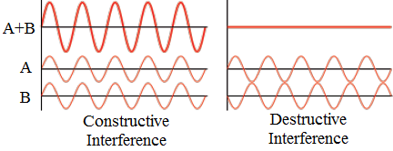

**Constructive interference** occurs when waves from two coherent sources meet to produce a wave of greater amplitude.

(Constructive interference occurs when the crests of one wave are over the crests of another wave).

**Destructive interference** occurs when waves from two coherent sources meet to produce a wave of lower amplitude.

(Destructive interference occurs when the crests of one wave are over the *troughs* of the second wave.

This will happen if one wave is half a wavelength out of phase with respect to the other).

**Coherent waves\***:two waves are said to be coherent if they have the same frequency and are in phase or have a constant phase difference between them..

*“In phase”* means crests stay over crests and troughs stay over troughs.

**Stationary (standing) waves**

**Stationary waves are waves where each point on the axis of the wave has constant amplitude.**

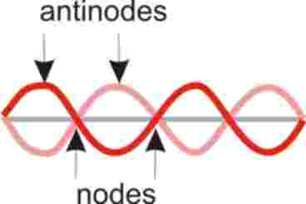Theyare formed when two periodic travelling waves of the same frequency and amplitude, travelling in opposite directions, meet.

The locations at which the amplitude is minimum are called nodes, and the locations where the amplitude is maximum are called antinodes.

From the diagram we can see that:

1. The distance between two consecutives nodes is λ/2
2. The distance between two consecutive antinodes is λ/2
3. The distance between an anti-node and the next node is λ/4

(“nodes” = “no” movement)

**The Doppler effect**

**The Doppler effect**is the apparent change in the frequency of a wave due to the relative motion between the source of the wave and the observer.

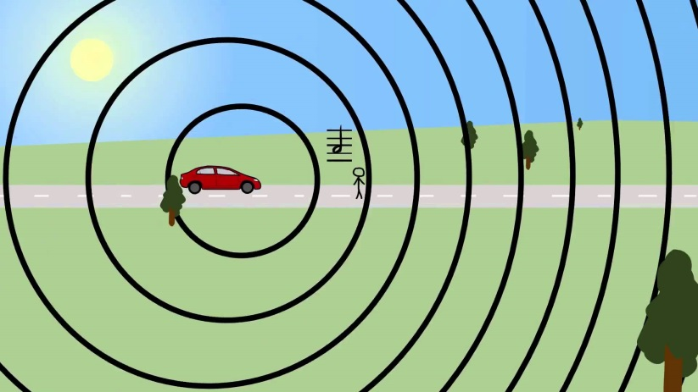

Consider the soundwaves emitted from a car’s engine with crests as shown as it moves to the right:

*Ahead* of the moving source, the crests are closer together than crests a the stationary source would be.

This means that the wavelength is smaller and the frequency is greater (more crests per second passing over the observer).

*Behind* the moving source, the crests are further apart than crests from a stationery source would be.

This means the wavelengths are greater and therefore the frequency is less (fewer crests per second passing over an observer behind the car.

**Explaining how the Doppler effect occurs (for exam purposes)**

Note that the marking schemes usually look for ***4*** separate points here:

1. A series of *non-concentric* circles.
2. Direction of motion of source and position of observer *must be indicated.*
3. Reference to *apparent change in wavelength.*
4. Reference to resulting *apparent change in frequency.*

**Mathematically we can work out apparent frequency of the wave using the following formula:**

*f*” = apparent frequency



*f* = actual frequency

*c* = speed of the wave

*u* = speed of the moving source

The sign below the line is negative if the source is moving towards the observer – **‘Minus Is Towards’ (MITS)**

***Practice re-arranging the variables in the formula to make both f and u the subject of the formula (with both the “-“ and the “+”). Each of these variations has been asked in past exams.***

**Sometimes you may have to use *c = fλ to get either f or f*” before you can use it in the Doppler formula itself.**

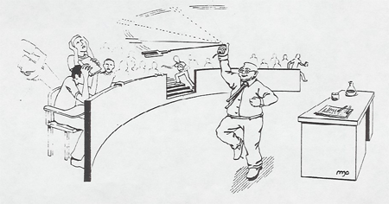**Note**:   
The noise from a racing car as it approaches and then moves away from an observer is *an example* of the Doppler effect – ***but*** ***it is not an application!!***

**Demonstration of the Doppler effect**

The Doppler effect for sound waves is dramatically demonstrated by swinging a ringing tuning fork around your head.

**Applications of the Doppler effect:**

1. Police speed traps
2. Measuring the red shift of galaxies in astronomy*
3. Using ultrasound to monitor the blood movement or heartbeat of a foetus.
4. Weather forecasting

**Leaving Cert Physics Syllabus**

|  |  |  |  |
| --- | --- | --- | --- |
| **Content** | **Depth of Treatment** | **Activities** | **STS** |
|  |  |  |  |
| 1. Properties of waves. | Longitudinal and transverse waves: frequency, amplitude, wavelength, velocity.  Relationship c = f λ | Appropriate calculations. | Everyday examples, e.g.   * Radio waves * Waves at sea * Seismic waves |
|  |  |  |  |
| 2. Wave phenomena | Reflection. Refraction. Diffraction. Interference. | Simple demonstrations using slinky, ripple tank, microwaves, *or* other suitable method. |  |
|  |  |  |  |
|  | Stationary waves; relationship between inter-node distance and wavelength. |  |  |
|  |  |  |  |
|  | Diffraction effects   * at an obstacle * at a slit   with reference to significance of the wavelength. |  |  |
|  |  |  |  |
| 3. Doppler effect | Qualitative treatment.  **Simple quantitative treatment for moving source and stationary observer.** | Sound from a moving source.  **Appropriate calculations without deriving formula.** | Red shift of stars.  Speed traps. |

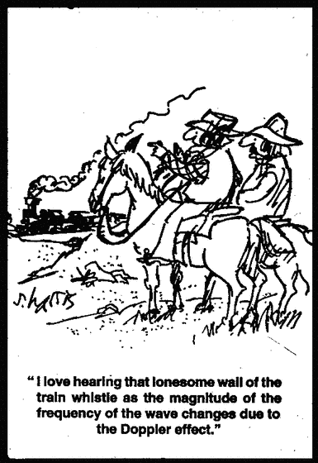

**Extra Credit**

**Earthquakes and Waves**

Earthquakes and violent volcanic eruptions are a source of seismic waves that result in planet Earth ringing like a bell for quite some time (up to weeks) after the "striking" event.

Less dramatically, the Earth "hums" all of the time with a collection of frequencies in the 1 to 10 mHz range.

This frequency translates into a period of typically 200s, which gives a clue to its origin.

Many sea-borne waves near to continental land masses (infragravity waves) have periods of this order of magnitude.

It is the interaction of these waves in the shallower water over continental shelves with the seabed that drive the "hum".

Most sea waves originate in the action of winds over the water surface.

In their turn winds derive their energy from the Sun's unequal heating of the Earth's surface and atmosphere.

So the Earth is humming to the tune of the Sun.

Reference: Nature 15th February pp754-756.

**Did you know?**

In avalanches it’s the shockwaves that is responsible for knocking trees and killing people, not the snow.

**\*The frequency of a wave is a measure of the number of oscillations (vibrations) of the wave per second.**  
Another way of defining frequency of a wave is to say it is the number of waves that pass a fixed point per second.  
This second definition is helpful in explaining the next point: T = 1/f

**\*Relationship between periodic time and frequency**  
**T = 1/f**  or  **f = 1/T**  
If three waves pass a fixed point per second (f = 3 Hz), it follows that the time for one wave to pass (periodic time T)

is 1/3 (seconds).  
Alternatively if the periodic time (T) is 1/5 seconds, it follows that five waves will pass in one second (f = 5 Hz).

**\*When a wave travels from one medium to another its frequency does not change**Basically if a wave ‘wobbles’ so many times a second in air, and then comes in contact with another medium e.g. water, the water will ‘wobble’ (move in and out) in sympathy with the driving force, and therefore at the same frequency. The speed however will change, and because speed is directly proportional to wavelength (from v = fλ), if the speed of the wave were to double (and the frequency remains constant) then the wavelength would double also.

**\*Diffractionis the spreading of waves around an obstacle**

This effect is only significantly noticeable if the slit is approximately the same size as the wavelength of the waves.  
So if the slit width is of the order of cm to metres, then sound may well be noticeably diffracted, depending on the frequency of the sound, because the corresponding wavelength may well be similar to the slit width.

However the same will not happen for light, because the wavelength for light is of the order of 10-7 metres, which doesn’t correspond to slits that one encounters every day.  
There are objects which are specifically designed to have these slit widths specifically so that light will diffract after passing through them. These are called ‘diffraction gratings’ and we will use them when studying Chapter 18: *The Wave Nature of Light*.

Similarly, compact dics have grooves in them which are approximately the same width as the wavelength of light, so shining white light on a CD gives a nice spectral pattern!

**So *why* is the effect only noticeable when the wavelength is the same size as the gap?**

Answer: I don’t know. If you can explain it or find someone else who can, please get back to me. I suspect it is another of those concepts which is a lot more technical than it first appears. But then maybe I just think that to make me feel better ☺

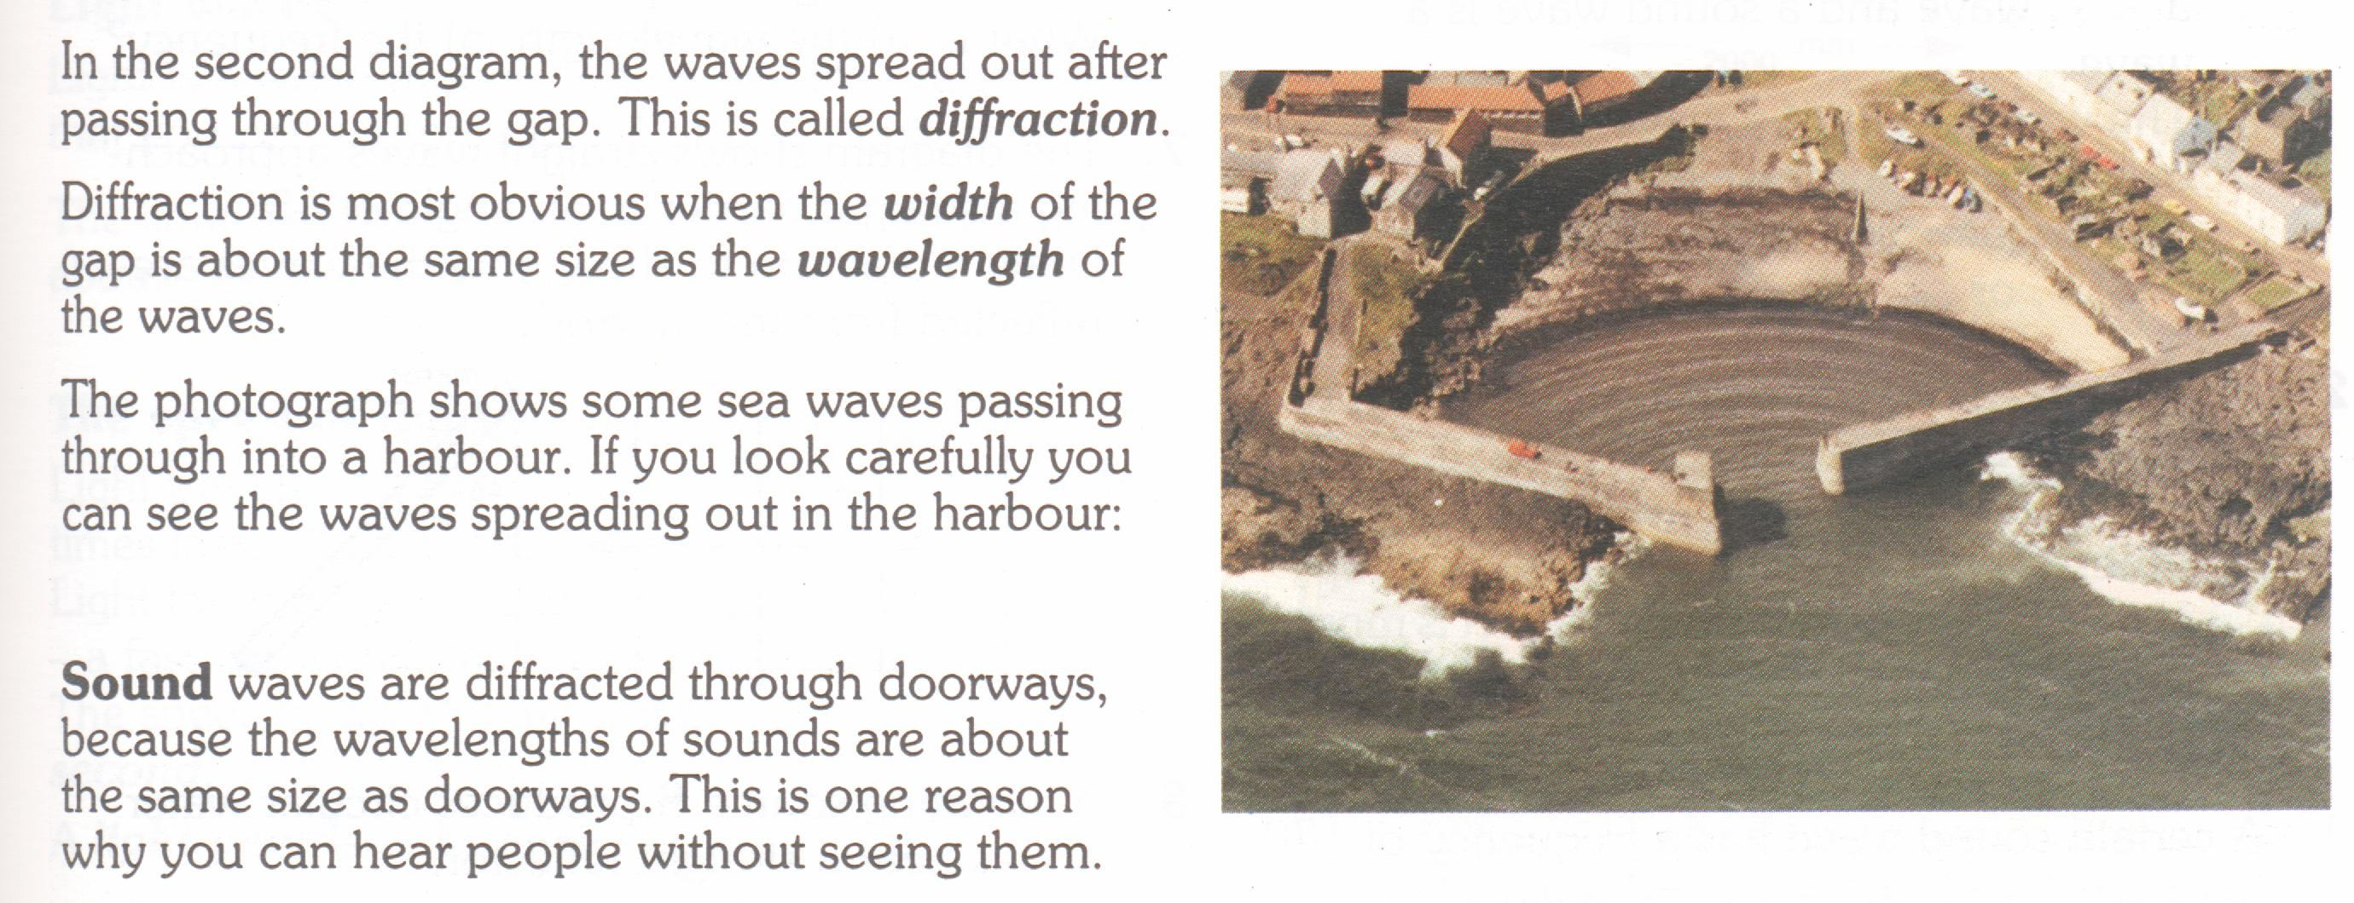

**\*Interference**

Interference is considered to be the most significant of the four characteristics because if a form of energy undergoes interference then it must be a wave (as opposed to travelling as particles). We know that both sound and light travel as waves because we can show that they undergo interference.

**\*Coherent Waves**

Strictly speaking the definition is a little more convoluted:

Two waves are said to be coherent if they have the same frequency (or wavelength) and are in phase (or have a constant phase difference between them)

Another necessary condition (for waves to be coherent) is therefore that both waves travel at the same speed.

**Uneven heating of food** (appalams illustrate this quite well)

You can use this phenomenon to get a rough estimation for the speed of light. Heat a layer of marshmallows or cheese in a microwave until they re-create the pattern shown. The concentric circles correspond to the crests of a standing wave, so the distance between two crests is half a wavelength.

You can read the frequency of the microwaves from the back of the oven, and then just use *c = f λ* to calculate the speed of the wave, which is also the speed of light.

Note that not all microwave ovens will create a pattern this noticeable.

\***Applications of the Doppler effect:**

Measuring the red shift of galaxies in astronomy

Strictly speaking the red-shift is due to two separate factors; other galaxies moving away from us *and* the fact that the space itself is expanding (our universe is expanding), so the distance between crests is increasing and this would happen even if the galaxies were not speeding away from us.

The fact that all galaxies are moving away from each other was first discovered by American astronomer Edwin Hubble. This expansion of the universe was one of the results of Einstein’s general theory of relativity, but at the time it was generally believed that the universe was not expanding, so Einstein put in a ‘fudge factor’ (called ‘the cosmological constant’) to make his equations come out in such a way that they ‘verified’ that the universe was not expanding. After Hubble’s discovery he described his fudge factor as ‘the greatest blunder of my life’.

By this stage Hubble had already made the even more staggering discovery that our galaxy was just one of a very large number of galaxies that seemed to inhabit the heavens – fundamentally changing our view of the universe.

What must it have been like to have made these discoveries?

The history of astronomy is sometimes referred to as ‘a history of receding horizons’.

That’s pretty cool.

Light waves ‘stretched’ – Red Shift

Light waves ‘squashed’ – Blue Shift

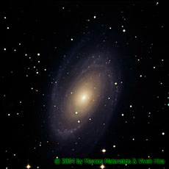

Galaxy receding

Galaxy approaching

**Exam questions**

Speed of sound = 340 m s-1

Speed of light = 3 × 108 m s-1

1. [2007 OL][2010 OL]

The diagram shows the waveform of a musical note.

What is the name given to (i) the distance A, (ii) height B?

1. [2007 OL][2010]

Explain what is meant by the frequency of a wave.

1. [2005 OL]

What is meant by the amplitude of a wave?

1. [2005][2006 OL]

Explain the difference between longitudinal and transverse waves.

1. [2005 OL]

A wave motion has a frequency of 5 hz and a wavelength of 200 m. Calculate the speed of the wave.

1. [2007 OL]

A tin-whistle produces a note of 256 Hz. Calculate the wavelength of this note.

1. [2010 OL]

If the natural frequency of a string is 250 Hz calculate the wavelength of the sound wave produced.

1. A mobile phone transmits at 1200 MHz from its antenna.

Calculate the length of its antenna, which is one quarter of the wavelength that it transmits.

(speed of light = 3×108 m s-1)

1. [2006 OL]
2. A ship detects the seabed by reflecting a pulse of high frequency sound from the seabed. The sound pulse is detected 0.4 s after it was sent out and the speed of sound in water is 1500 m s–1.

Calculate the time taken for the pulse to reach the seabed.

1. Calculate the depth of water under the ship.
2. Calculate the wavelength of the sound pulse when its frequency is 50 000 Hz.
3. [2004 OL][2002 OL][2005 OL][2009]

Explain the term *diffraction*.

1. [2004 OL][2005 OL]

Explain the term *interference*.

1. [2008]

Why does diffraction not occur when light passes through a window?

1. [2006]

A sound wave is diffracted as it passes through a doorway but a light wave is not. Explain why.

1. [2002]

Explain the term *constructive interference*.

1. [2002]

Explain the term *coherent sources*.

1. [2007]

What is the condition necessary for destructive interference to take place when waves from two coherent sources meet?

1. [2004 OL]
2. The diagram shows a stationary wave (standing wave) on a vibrating stretched string.

What is the name given to the points on the string marked (i) X, (ii) Y?



1. How many wavelengths are contained in the distance marked L?
2. A note of wavelength 1.4 m is produced from a stretched string. If the speed of sound in air is 340 m s−1, calculate the frequency of the note.



1. [2005]
2. The diagram shows a guitar string stretched between supports 0.65 m apart.

The string is vibrating at its first harmonic.

The speed of sound in the string is 500 m s–1.

What is the frequency of vibration of the string?

1. Draw a diagram of the string when it vibrates at its second harmonic.
2. What is the frequency of the second harmonic?
3. [2006]

A stretched string of length 80 cm has a fundamental frequency of vibration of 400 Hz.

What is the speed of the sound wave in the stretched string?

**The Doppler effect**

1. [2008 OL]

The pitch of a note emitted by the siren of a fast moving ambulance appears to change as it passes a stationary observer. Name this phenomenon.

1. [2008][2007][2006][2003][2002][2010]

What is the Doppler effect?

1. [2010]

Describe a laboratory experiment to demonstrate the Doppler effect.

1. [2007][2003][2008 OL][2010]

Explain, with the aid of labelled diagrams, how the Doppler effect occurs.

1. [2002 OL]

Give an example of the Doppler Effect.

1. [2008][2003][2004 OL][2007 OL]2008 OL][2010]

Give two applications of the Doppler effect.

1. [2010]

What causes the red shift in the spectrum of a distant star?

1. [2005]It is noticed that the frequency of the received radio signal changes as the satellite orbits Saturn. Explain why.
2. Rearrange the Doppler effect formula to make ***u*** the subject of the formula (using the ‘minus’ version).
3. Rearrange the Doppler effect formula to make ***f*** the subject of the formula (using the ‘minus’ version).
4. [2008]

A rally car travelling at 55 m s–1 passes a stationary observer.   
Its engine is emitting a note with a pitch of 1520 Hz.   
What is *the change* in pitch observed as the car moves away?   
Take the speed of sound to be 340 m s-1.

1. [2003]
2. Bats use high frequency waves to detect obstacles.

A bat emits a wave of frequency 68 kHz and wavelength 5.0 mm towards the wall of a cave.

Calculate the speed of the wave.

1. If the apparent frequency of the reflected wave is 70 kHz, what is the speed of the bat towards the wall?

*{From the bat’s perspective the wall is now sending out a wave at a frequency of 68 kHz (the frequency of the wave doesn’t change just because it was reflected).*

*Now because the bat is moving towards the source (the wall) we will need to use ‘minus’ rather than ‘plus’ in the formula.*

*This is also an example of where the concept of* ***relative*** *motion applies; rather than the source of the wave moving towards the observer (the bat), the observer in this case is moving towards the source)}*

1. [2010]   
   **{Tricky - leave this as a revision question for sixth year***587 nm means 587 × 10-9 m  
   Here you are given wavelength but you need the corresponding frequency to use the Doppler formula so use c=fλ to find f each time}*

The yellow line emitted by a helium discharge tube in the laboratory has a wavelength of 587 nm.

The same yellow line in the helium spectrum of a star has a measured wavelength of 590 nm.

1. What can you deduce about the motion of the star?
2. Calculate the speed of the moving star. Take the speed of light to be 3 × 108 m s-1.
3. [2007] **{Tricky - leave this as a revision question for sixth year}**
4. The red line emitted by a hydrogen discharge tube in the laboratory has a wavelength of 656 nm.

The same red line in the hydrogen spectrum of a moving star has a wavelength of 720 nm.

Is the star approaching the earth? Justify your answer.

1. Calculate the **actual** frequency of the red line.
2. Calculate the speed of the moving star. Take the speed of light to be 3 × 108 m s-1.

**Exam Solutions**

1. A = wavelength

B = amplitude

1. The frequency of a wave is the number of waves passing a fixed point per second.
2. Amplitude corresponds to the height of the wave.
3. A Transverse wave is a wave where the direction of vibration is *perpendicular* to the direction in which the wave travels.

A Longitudinal Wave is a wave where the direction of vibration is *parallel* to the direction in which the wave travels.

1. c = f λ ⇒ c = 5 × 200 = 1000 m s-1.
2. The speed of sound in air is 340 m s−1

c = fλ ⇒λ = c/f ⇒ λ = 340/256 = 1.33 m.

1. v = f ***λ***

***λ*** = v/f

***λ*** = 340/250

= 1.36 m

1. λ = c/f

λ = (3 × 108)/(1.2 × 109)

λ = 0.25 m

Length of antenna = 0.25/4 = 0.0625 m.

1. 0.2 s.
2. v= s/t ⇒ s = v × t ⇒ s = 1500 × 0.2 = 300 m.
3. c = fλ ⇒ λ = c/f ⇒ λ = 1500/50000 = 0.03 m.
4. Diffractionis the spreading of waves around a slit or an obstacle.
5. Interference occurs when waves from two sources meet to produce a wave of different amplitude.
6. The window is too wide (relative to wavelength of light).
7. Diffraction only occurs when the width of the gap is approximately equal to the wavelength of the wave. This is the case for a sound wave but the wavelength of a light-wave is very small compared to the size of a doorway.
8. Constructive Interference occurs when waves from two coherent sources meet to produce a wave of greater amplitude.
9. Two waves are said to be coherent if they have the same frequency and are in phase.
10. They must be out of phase by half a wavelength (this means that the crest of one wave will be over the trough of the other.
11. ****X = node, (ii) Y = antinode
12. Answer: 2
13. c = fλ ⇒ 340 = f × 1.4 ⇒ f = 242.9 Hz
14. v = f λ  **** v = 400(1.6) = 640 m s-1
15. λ = 2 × 0.65 = 1.3 m

*v = f*λ  *f = v/* λ = 500 / 1.3  *f* = 384.6 Hz

1. See diagram
2. f2nd = 2f1st  = 769.2 Hz

**The Doppler Effect**

1. The Doppler effect.
2. Attach a string to a buzzer.

Swing the buzzer over your head.

An observer will note a frequency change as the buzzer approaches then recedes from source the observer.

1. The Doppler Effectis the apparent change in the frequency of a wave due to the relative motion between the source of the wave and the observer.
2. Non-concentric circles labelled as *waves*

Source and direction of motion (stated/implied)

Position of observer indicated

Close parts of circles show short wavelength

Shorter wavelength implies higher frequency on approaching observer (or vice versa)

1. The pitch of an ambulance changes as it goes past.
2. Distant stars are moving away from us therefore the wavelengths increase.
3. Calculate speeds of stars or galaxies, speed traps.landing aircraft, ultrasound (blood movement or heartbeat of foetus), weather forecasting.
4. Doppler Effect due to relative motion between source of signal and the detector
5. 

⇒ 

⇒ f1 = 1308.35 Hz

⇒ change in frequency = 1520 – 1308.35 = 211.65 Hz.

1. v = fλ = 68000 ×.005 **=** 340 m s-1
2. f ' = fc / c± u

70000 = (68000)(340)/(340 – u)

u = 9.7 m s-1

1. The star is moving away from earth
2. 

Substitution: c = 3 × 108, f = 5.11073× 1014 and f’ = 5.08475× 1014

Answer: u = 1.53 × 106 m s-1

1. No; the wavelength has increased therefore it must be moving away.
2. f’ = c / λ’

f’ = 3×108/720×10-9  f’ = 4.17 × 1014 Hz

1. Formula: f’ = fc/c+u

Substitution: 4.17 ×1014 = (4.57 ×1014)(3 ×108) / (3.00×108 + u)

Answer: u = 2.92 × 10 7 ms-1

